IUPAP-C13工作会议小结
龙桂鲁
2010-9-8

2010-8-28在意大利ICTP召开了C13的工作会议。参加会议的委员见附件1，会议议程见附件2。特邀代表包括：1）ICTP主任 (F. Quevedo)，2）EPS代表François Piuzzi (EPS) ;3) C14(教学委员会)主任，Prof. Pratibha Jolly (C14)。

会议主要内容：
- 新增副委员、ICTP主任F. Quevedo介绍了他对ICTP发展的理念和计划。另两名新增副委员Haiwong Lee、A. Hoummada因故没有参加本次会议。
- 嘉宾发言，François Piuzzi (EPS Inter-divisional Group on Physics for Development )介绍了EPS与发展相关的活动，如利用废弃的仪器改造成为教学设备等；Pratibha Jolly (International Commission on Physics Education)介绍了开展Hands-on物理教学的进展。
- 介绍2009年批准的在南非举行的计算凝聚态系列讲习班的情况。龙桂鲁介绍了亚欧峰会和APCTP的活动情况；DIPALi介绍英国物理学会在非洲的支教活动；fairouz介绍法国在非洲的支教活动。今年共收到四个会议资助申请，分别来自Cameroon (Denes)、Tunisia (Jaimie)、Cuba和Brazil，会议讨论及投票结果是，建议前两个项目分别给予1万欧元和7千欧元的资助。
- 讨论了Visiting Scientist Program，将罗马尼亚从可申请国中划掉。
- 2011年会议还将于8月底进行，会议将延长至两天。

C13的援助对象主要是非洲，对亚洲有所忽略。会议期间，有的委员告诉我，中国在非洲有许多投资，应加强在软设施方面的建设。

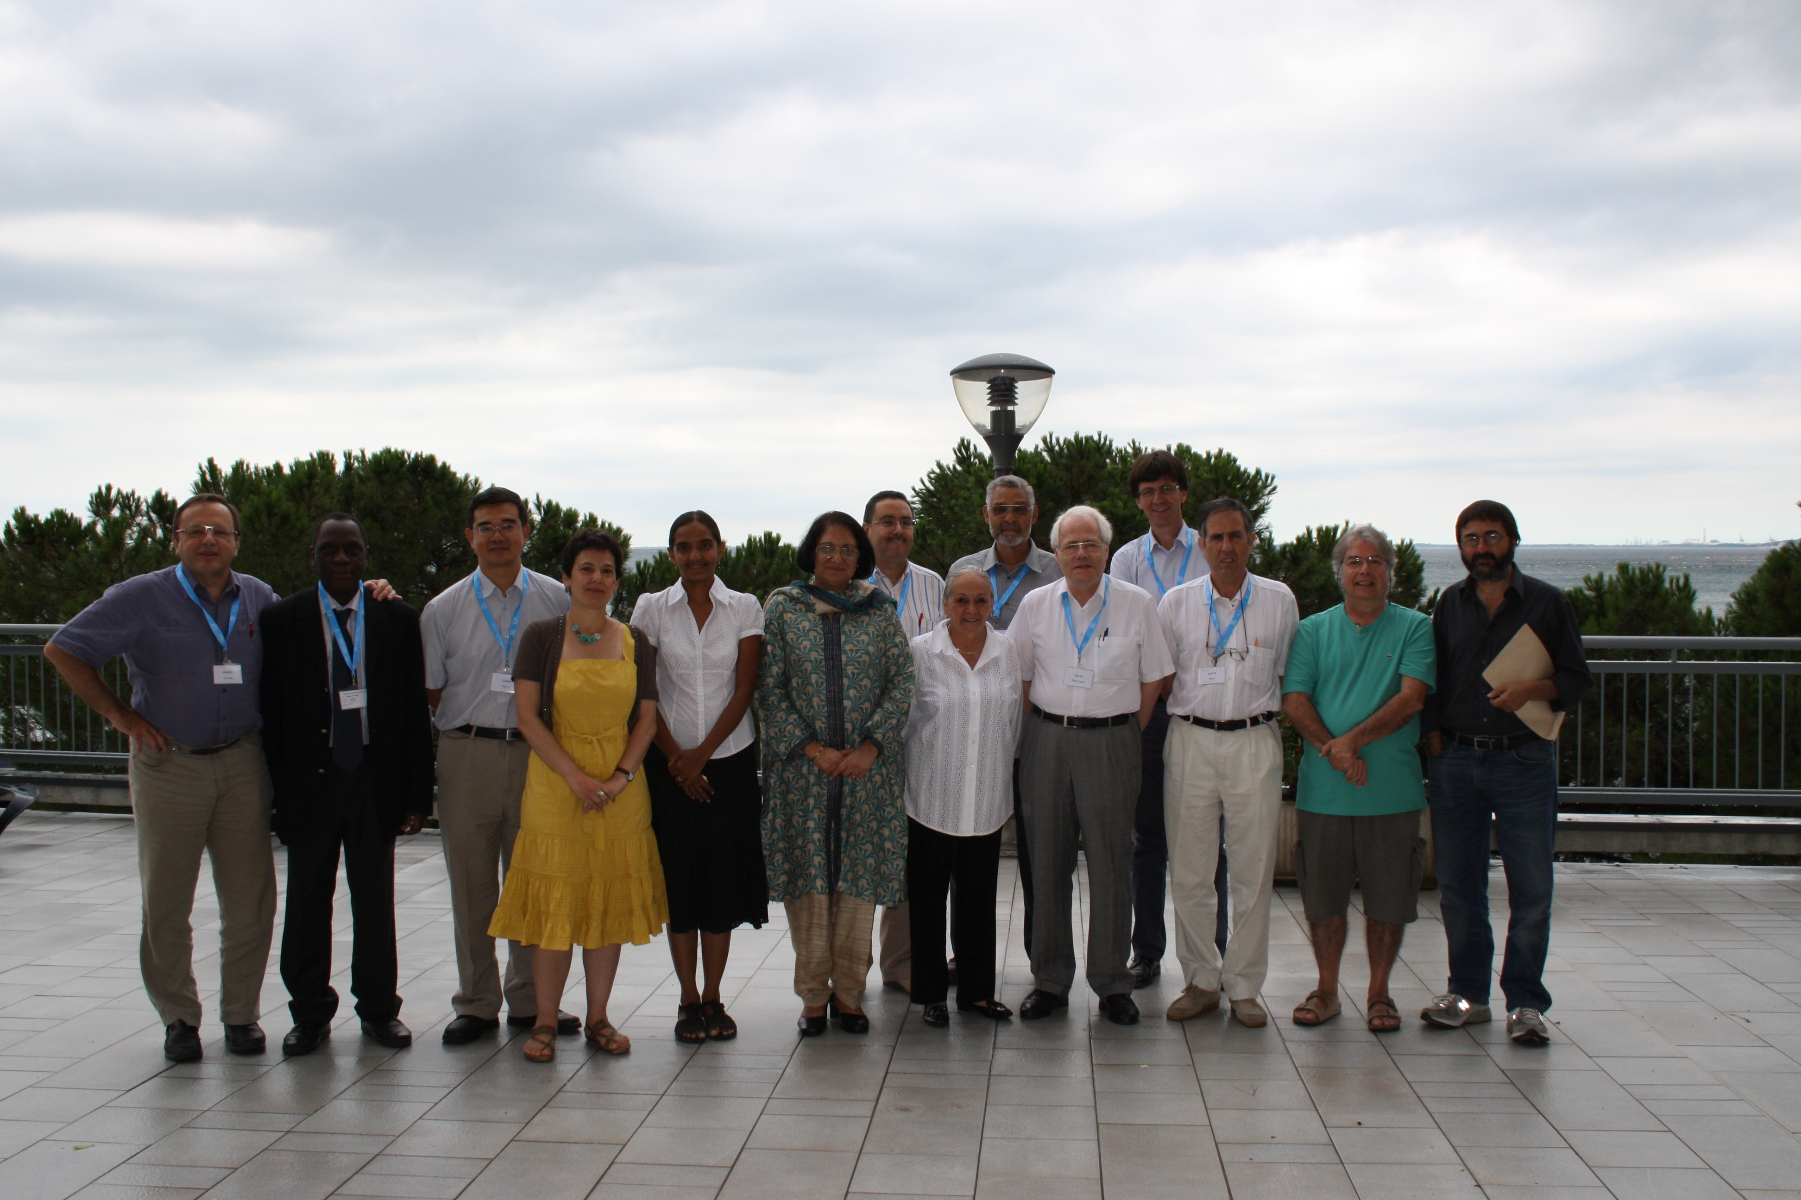
会议部分代表合影（自左至右：Piuzzi，Wague，龙，Fairouz, Dipali, Jolly, Mourad, Carmen, Kennedy, Genes, Sandro, Jueve, Oliveria, Quovedo）

附件1：参加会议的C13委员

Chair Kennedy REED USA reed5@llnl.gov
Vice Chair Ludger WOESTE Germany woeste@physik.fu-berlin.de
Secretary Sandro SCANDOLO Italy scandolo@ictp.it

MEMBERS
1. Dirk CALLEBAUT Belgium dirk.callebaut@ua.ac.be
2. Carmen CISNEROS Mexico carmen@fis.unam.mx
3. Jaime JULVE Spain julve@imaff.cfmac.csic.es
4. Dipali CHAUHAN UK dipali.chauhan@iop.org
5. Guilu LONG China-Beijing gllong@mail.tsinghua.edu.cn
6. Fairouz MALEK France fmalek@lpsc.in2p3.fr
7. Denes Lagos NAGY Hungary nagy@rmki.kfki.hu
8. Paulo OLIVEIRA Brazil pmco@if.uff.br
10. Mourad TELMINI Tunisia mourad.telmini@fst.rnu.tn
11. Ahmadou WAGUE Senegal wague@refer.sn

附件2：会议议程
Meeting of the IUPAP Commission on Physics for Development (C13)
Saturday August 28, 2010 9h30-17h30
The Abdus Salam International Centre for Theoretical Physics (ICTP)
Trieste, Italy

Venue: Adriatico Guest House (Lundqvist Lecture Room), Via Grignano 9, Miramare-Trieste

Agenda:
- Welcome and presentations.
Invited Guests: Dr. Barbara Sandow (Free Univ-Berlin); Prof. François Piuzzi (EPS) ; Prof. Pratibha Jolly (C14)
- Review of activities of Institutes and Societies for “Physics for Development”:
- African Physical Society (A. Wague)
- Brazilian Physical Society (P. Castro de Oliveira)
- ICTP (F. Quevedo)
- Moroccan HEP Cluster (A. Hoummada，没参加))
Break
- Guests and Collaborators
- Barbara Sandow (IUPAP Working Group on Women in Physics，没参加)
- François Piuzzi (EPS Inter-divisional Group on Physics for Development )
- Pratibha Jolly (International Commission on Physics Education)

LUNCH

- C13 and C20 Collaboration on African School on Electronic Structure Methods and Applications (ASESMA 2010), (Sandro)
- General discussion on collaborative activities (All)
Break
- Conference proposals for 2011 submitted to C13 for support by IUPAP: Application from Cameroon (Denes); Application from Tunisia (Jaimie); Application from Cuba; Application from Brazil; Discussion (All); Recommendations and ranking to be sent to IUPAP Council.
- Visiting Scientist Program (Kennedy)
- Information on ASEPS and APCTP (Gui-Lu); Information on EUMEDGRID and EPIKH (Fairouz), Information on IOP (Dipali)
- Other Business

